Chip back potential is the level which bulk silicon is maintained by on-chip connection, or it is the level to which the chip back must be connected when specifically stated below. If no potential is given the chip back should be isolated.

.025”

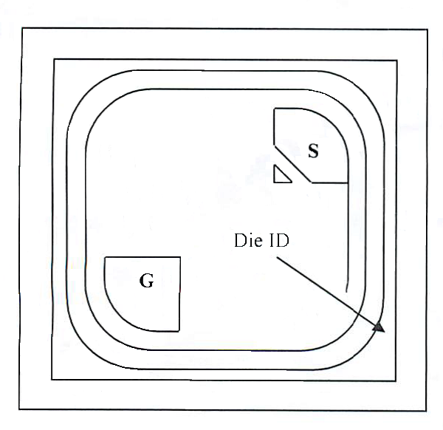

.025”

NOTE: Die backside connection is DRAIN

Top Material: Al
Backside Material: TiNiAgSn
Bond Pad Size: .005” X .005” min.
Backside Potential: DRAIN
Mask Ref: 9GA

APPROVED BY: DK DIE SIZE .025” X .025” DATE: 4/8/21
MFG:FAIRCHILD SEMI THICKNESS .008” P/N: 2N7000
DG 10.1.2

Rev B, 7/19/02

